ECE 492 Seamless Physiological Monitoring Design Proposal

Prepared for:
Professor Nathalia Peixoto

Prepared by:
Saad Abdullah
Moneeb Ahmad
Aayush Aryal
Priyam Das
Ryan Gunawan
Muhammed Jamil Rahman

II. Summary of Motivation, Identification of Need and Requirements definition.

Motivations:
It is easy for someone to get hooked onto a certain activity or hobby that they participate in for entertainment or for stress alleviation. Gaming can be a fun and an addictive hobby, however, it can sometimes be hard for a gamer to know when to quit playing. The amount of time a gamer spends playing video games has steadily increased, from 5.1 h/week in 2011 to 6.5 h/week in 2019 [1]. This extended period of gaming can be detrimental to a gamers psychological well-being as well as causing issues with their health. In the DSM-5, the American Psychiatric Association defined Internet Gaming Disorder with diagnostic criteria closely related to Gambling Disorder [1]. As for physical health, extended gaming can cause major repercussions such as Carpal Tunnel Syndrome (CTS). CTS is an instance of pain, numbness, and/or tingling that occurs as a result of this nerve being pinched, squeezed, or compressed [2]. Most often, CTS will arise due to a series of repetitive movements performed over a long period of time, for example, a gamer typing on a keyboard or button-mashing a controller. As gaming continues to grow in popularity these physical and psychological issues that are associated with long gaming sessions will continue to arise in frequency. In order to mitigate these issues we plan on creating a device that will be used to monitor a gamers psychological and physical health while they are gaming. If the device detects any health issues that are arising in the gamers, then the device will send an alert to the user letting them know to take a break from their gaming session. With the implementation of this device, a gamer can continue to enjoy their hobby while also retaining their psychological and physical health.

Identification of Need:
This Seamless Physiological Monitoring product will constantly monitor and measure a user’s mental and physical health while they are gaming for an extended period of time. The device will record a user’s stress level, heart rate, body temperature, movement and alert them if their levels are high. The data that is being recorded from a user will also be uploaded to a cloud-based dashboard for off-site monitoring. The data will also be displayed to the user through an LCD screen where they can cycle through their different measurements in real time.

Project Requirements Specifications
Mission Requirements
- The device shall measure the physical and mental health of gamers.
Operational Requirements
- Input/output requirements
  - The device will have multiple sensors on in order to calculate a user's symptoms and display it onto a simple LCD screen.
  - The device shall accept an input from a user through a push button in order to allow users to cycle between different monitoring sections on the LCD screen.
  - Data will be stored onto a cloud system.
- External Interface requirements
  - The deceive will be battery powered.
- Functional Requirements
  - The device will use the sensors to collect a user's symptoms every 10 milliseconds.
  - The device should detect errors and provide visual notification.
  - The device will alert the user if their stress level, heart rate, body temperature, or wrist movement is at a high rate for an extended period of time.
- Technology and System-wide requirements
  - The cloud storage system that will be used for this project is Azure.
  - The program languages that will be used for this project are C and Python.
  - The sensors that will be used in this project are: Reflection-Type Heart Sensor, Accelerator, Temperature Sensor.
  - The Microcontroller that will be used for this project is a MSP430-EXP430G2ET.
  - An LCD display as well as a wifi card will be used in this project.
  - The buses that will be used in this project will be I2C and UART.
  - The cost for this project will be less than $600
  - The power requirements for this project will be less than 15 volts.

III. System Design/ Architecture - System Decomp and Interfaces
Functional Decomposition
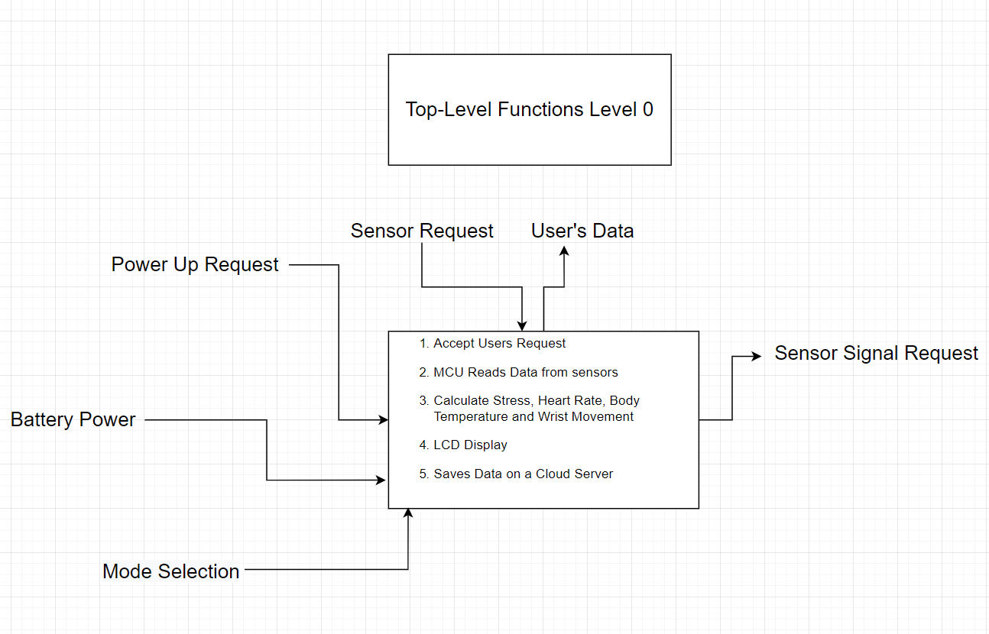
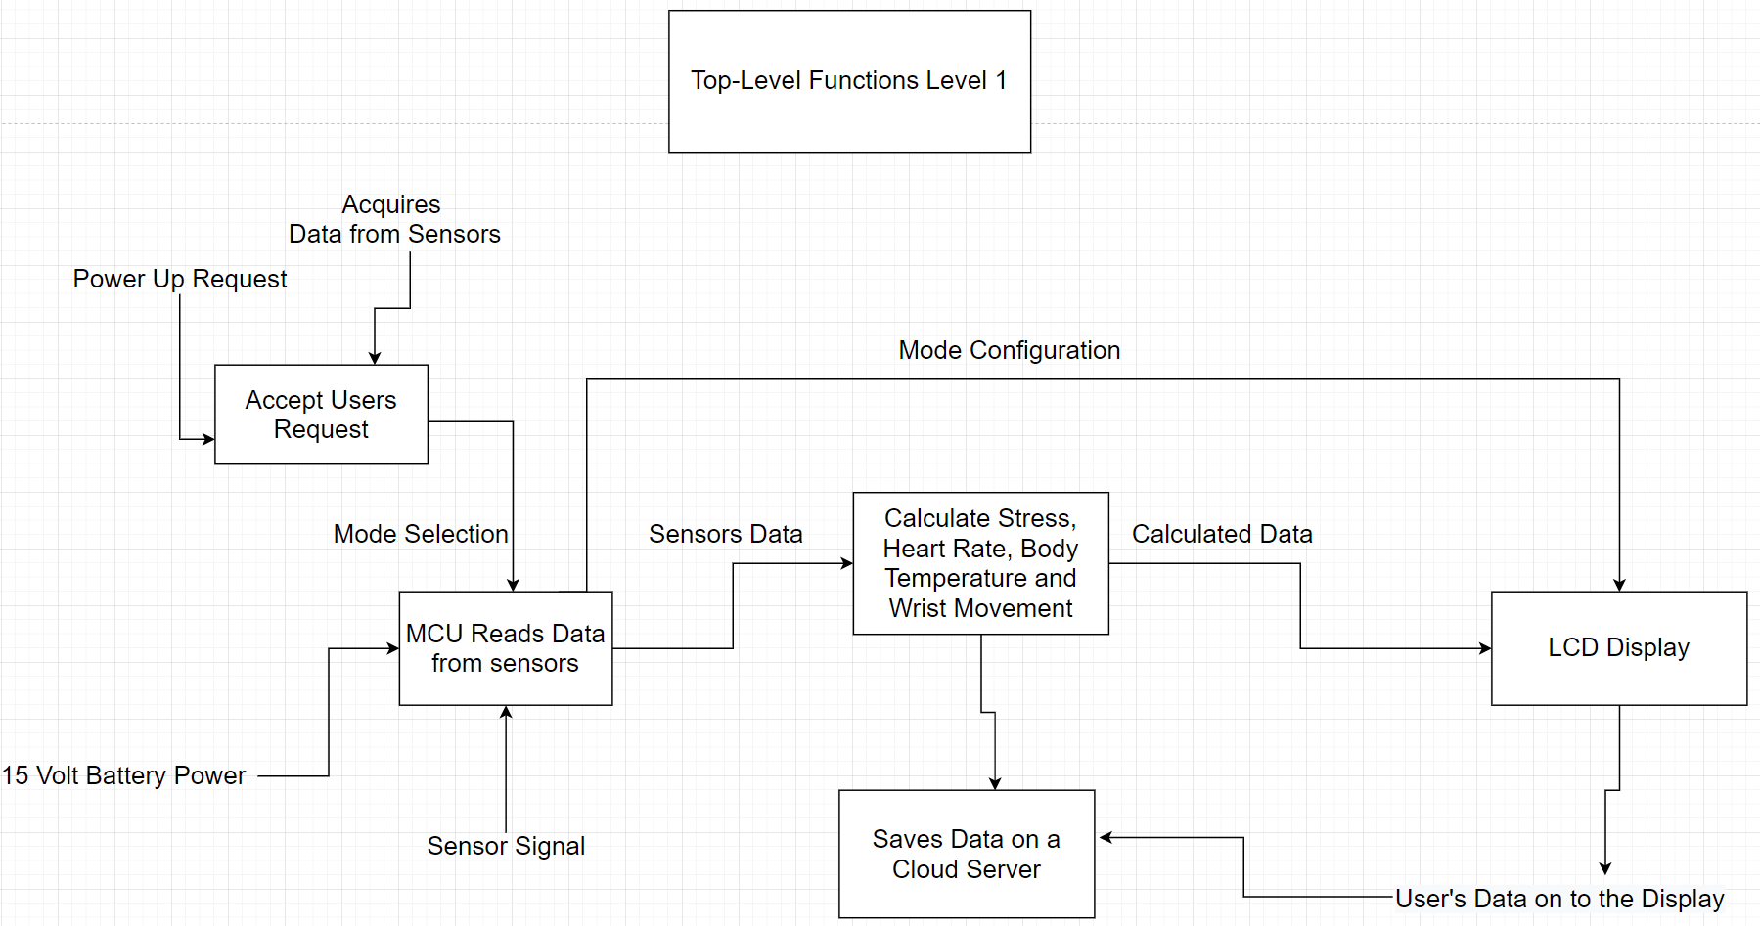
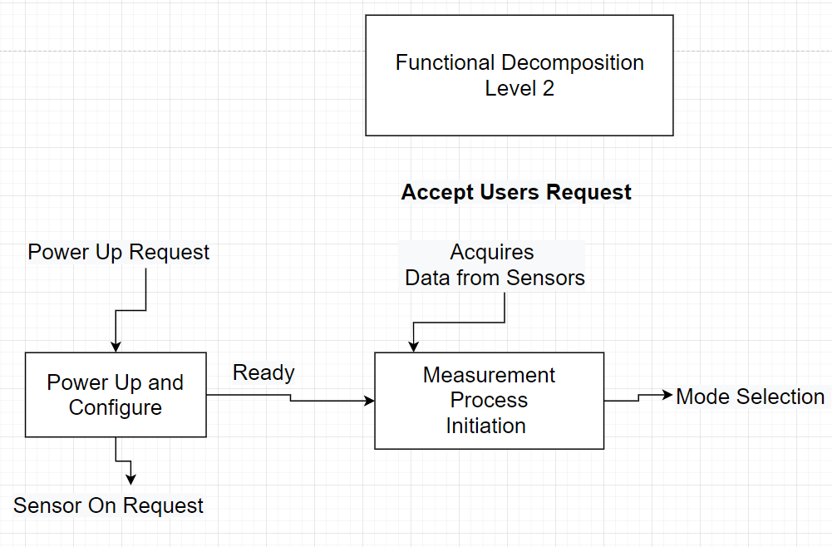
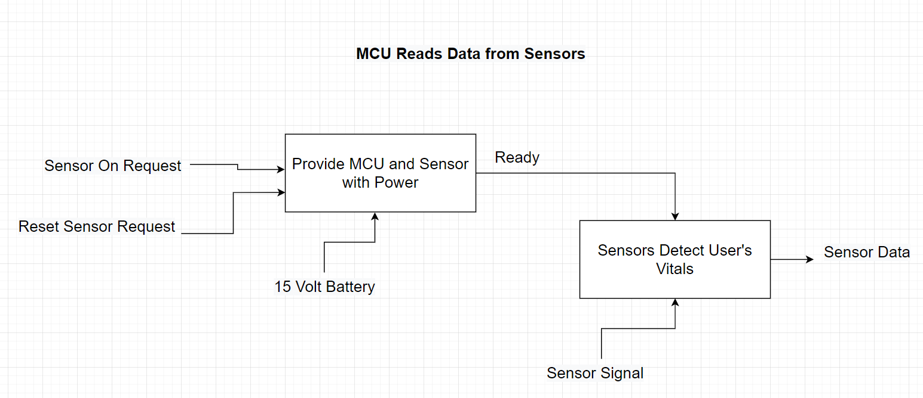

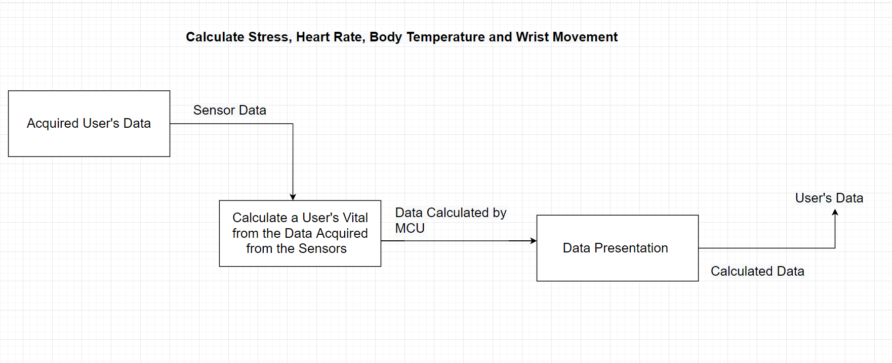

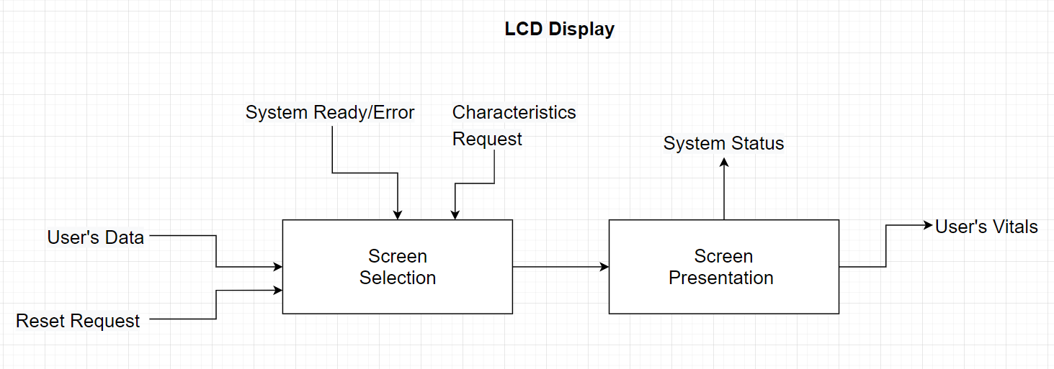
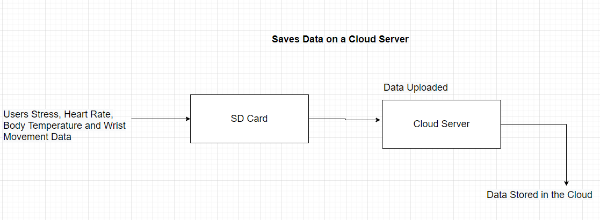

Generic Physical Architecture
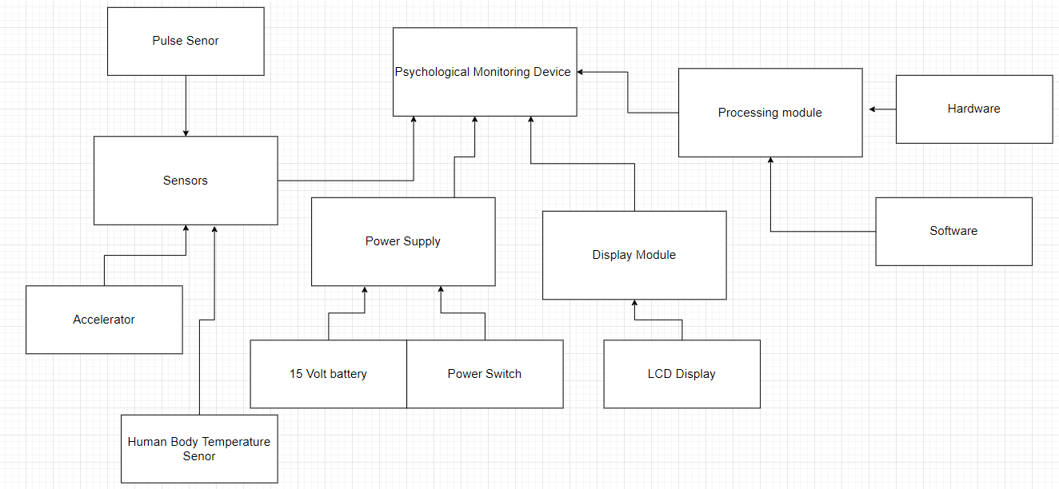

System Architecture
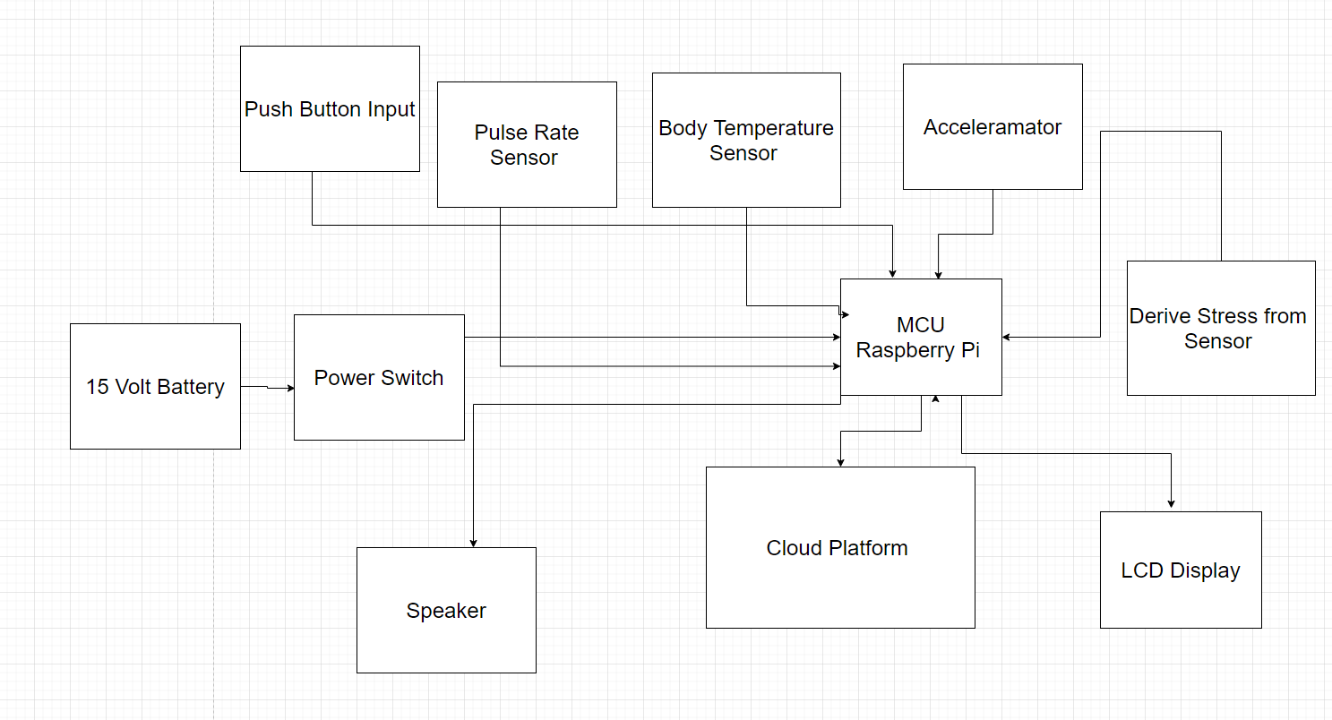

IV. Detail Design - (a) Circuit Schematic level (b) flow diagrams with identifications of subroutines

A.) Circuit Schematic Level

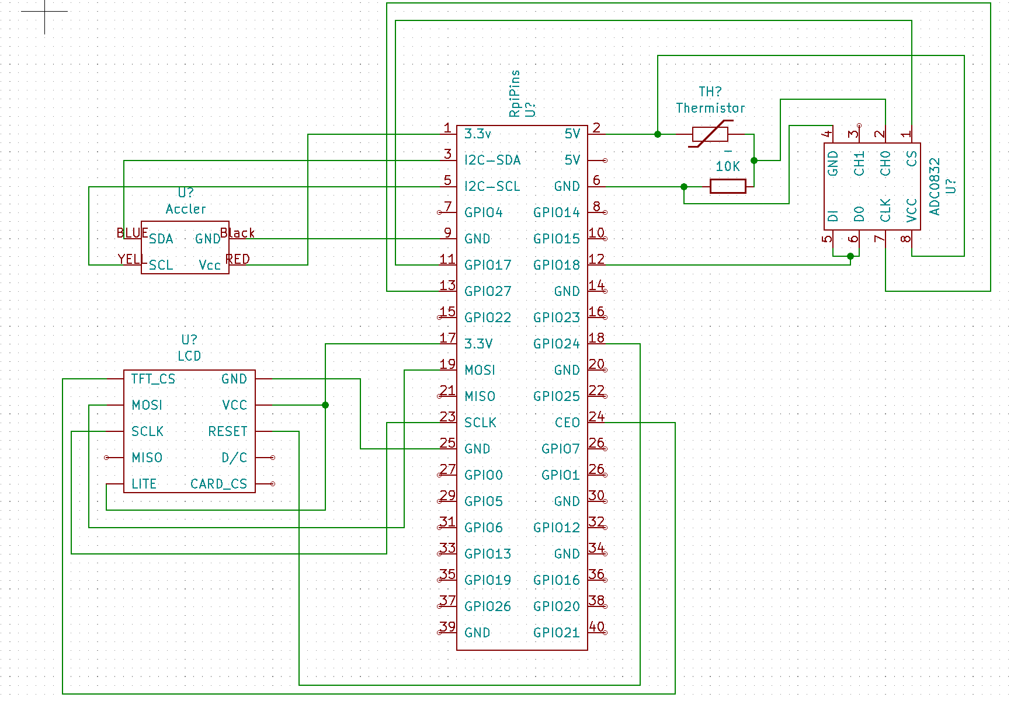

B.) State Diagram

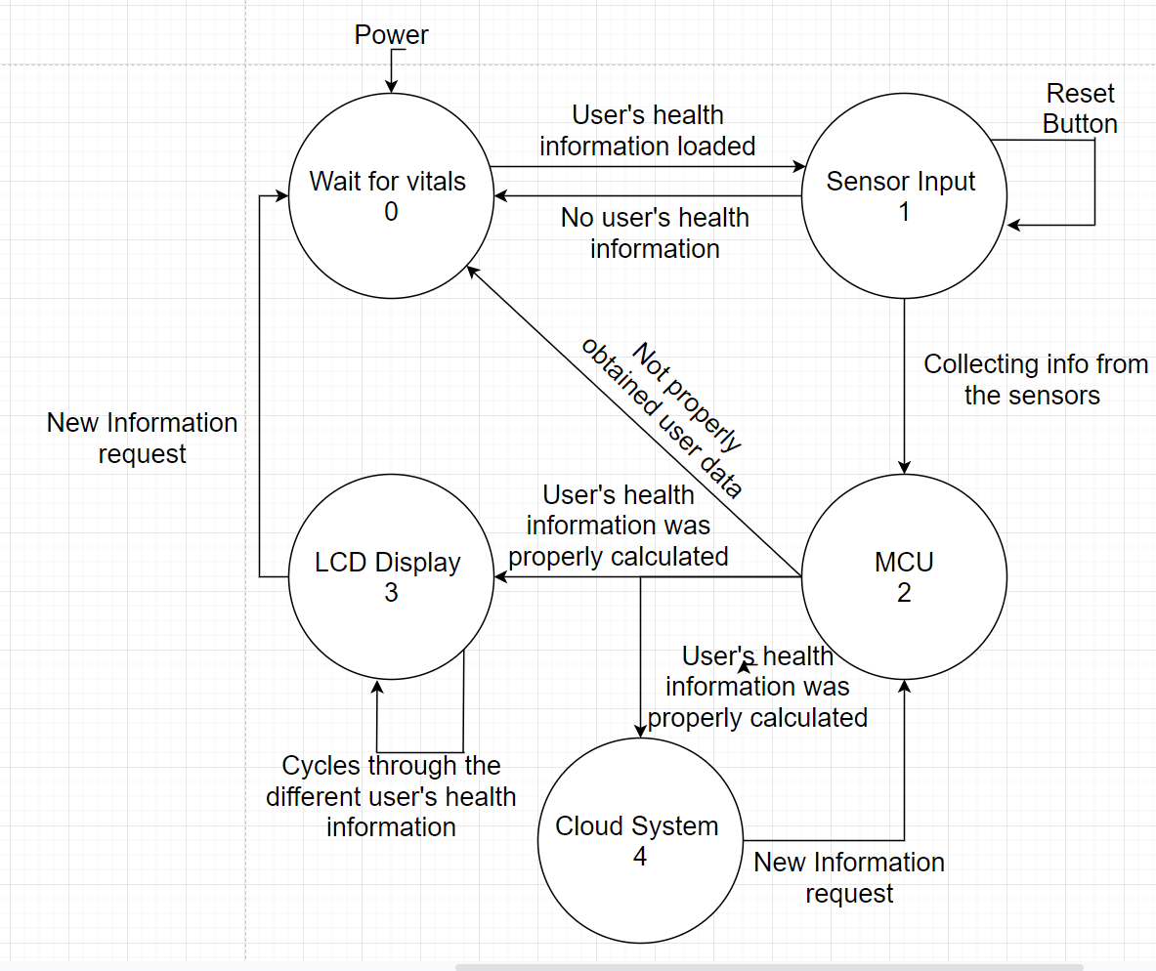

C.) Software Design

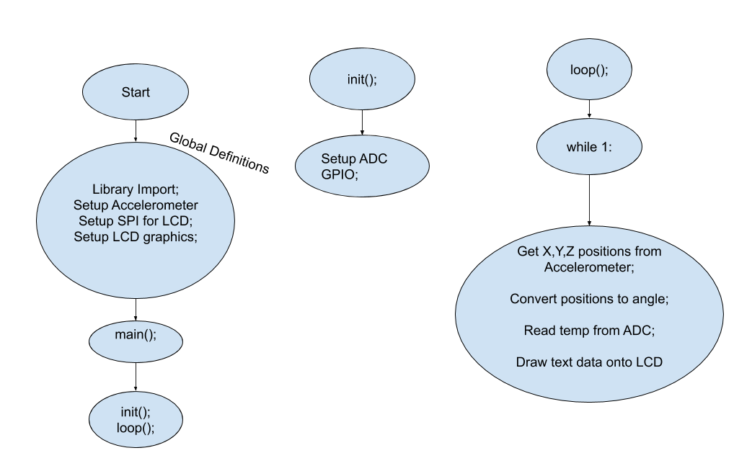

V. Prototyping progress report - what was built / experimented with, etc.

Prototyping is an important part of this project as it ensures that we have properly designed our portable health monitoring device to work as intended. Although having a slow start we have made a significant amount of progress in creating working portions in our health monitoring device. One of the requirements for this project that we have implemented so far is analyzing a user’s body temperature. In order to analyze their temperature we used a thermal resistor which was paired up with an ADC chip which would then send the data of the sensor to the Raspberry Pi. Once the Raspberry Pi received the data we wrote a program that would analyze the data and convert it into a temperature reading. Another part of the device that we have successfully implemented is tracking a user’s wrist movement using an accelerometer. In order to test our accelerometer we connected it to a breadboard which would then send the information to the Raspberry Pi via the I²C protocol. The last portion that we have successfully completed is configuring the lcd to display a user’s health information. The screen was able to show both the user’s wrist angle and body temperature in real time.
Although we have not successfully implemented it yet we have made a significant amount of progress in implementing the pulse rate sensor into our design so it can read a user’s heart rate. We were able to design the code which enables the raspberry pi to interpret the information that is produced from the pulse rate sensor however we weren’t able to properly test it. This is because the pulse rate sensor was delayed during shipping and has just gotten here recently. We plan on testing out our code design for the pulse rate sensor once we are able to meet again. After we are able to verify that the pulse rate sensor code runs correctly we will then be able to determine the stress level of the user. Once the code which is used to determine a user’s stress level is verified we will then design an infrastructure using ThingSpeak in order to upload all of the user’s health information into the cloud.

VI. Experimentation plan

This project contains sensors, a power supply, an LCD display and microcontroller. There will be two experiments to test the readiness of the final product: operational requirement evaluation and functional requirement evaluation.

Experiment 1 (Operational Requirement Evaluation):
Goal: To evaluate a user's input and selection using a push button
System Components: LCD, Sensors and Push Button
Testing Process: A user can select through different modes on the Psychological device by clicking on a button in order to see their health data while gaming. The user will be able to click on the button multiple times in order to see the different reading that the device is displaying.
Evaluation: We will verify that once a user pushes the button the LCD on the device it has changed modes in a proper cycle.
Experiment 2 (Functional Requirement Evaluation)
Goal: To evaluate measurements of a user’s: stress level, heart rate, body temperature, and wrist movement.
System Components: Sensors, Microcontroller.
Testing Process: We will be using the sensors that are encased in the device in order to measure a users physical and psychological health while they are gaming. The Microcontroller will convert the data that is collected from the sensors into readable data that the user can view.
Evaluation: We will verify that the data that is being collected from the sensor is accurate by using 3rd party health equipment (ie; apple watch) in order to measure a user’s health and then compare it to our device reading. This test process will be conducted multiple times in order to assure that the Psychological device that we are creating is consistently outputting the correct information about a user’s health.

VII. List of tasks for 493 and their decompositions into subtasks plus individual responsibility

- PCB design- We have used KiCad to design the schematic we will be implementing on a PCB board for our project. We will be hierarchical schematics so that it will enforce organization to our schematics and help us guide through the designing process. To make it aesthetically pleasing, we are going to make it as neat and clean as possible so that whoever tries to follow the pcb design has a good grip on how to integrate individual devices without confusion. Before placing the sensors in the PCB board, we will verify our circuit board layout by running a design rule check (DRC). Another goal for this part of the project is to make design as small as possible. This will help us fit everything into a compact, light-weight watch which will be feasible to wear anywhere.
- Cloud server: In order to store the data we collect from our device, we will use ThingSpeak as a cloud server. ThingSpeak is an open IoT platform for monitoring data online. In ThingSpeak channel we can set the data as private or public according to our choice. ThingSpeak generally takes 15 seconds to update the readings. After creating an account, we will open our own channels where the uploaded data will be visible. Each channel will contain different data collected from the sensors. For example, one channel will contain the body temperature information and variation. Another channel will store the body movement information. Our unique code will calculate the stress level from the sensors and will upload it simultaneously. The users will have access to this information anytime they want to check for it.
- 3d printed case - after we are done with our exhaustive testing, we will be using a 3D printer to create our own case that will hold our device. We have already designed our case using “Blender” and created the STL file. It will take approximately 3 days to form the 3D printer to build the design.
- Testing - We will be conducting extensive testing on our device to make sure the device is performing correctly and efficiently. We will make sure all the sensors are working properly and the connections are in correct order as well as safe. We will monitor how effectively the device is uploading data to the cloud server and if the data sent is accurate. In addition, we will be testing the device on different types of users from different age categories to make sure the device functions properly and is able to differentiate between different users. We will be testing the integrity of the device in various circumstances to see if the device is securely able to stay on the user’s body as well as perform the tasks correctly.

Responsibilities:

Saad | Cloud Server setup
Moneeb | Integration of individual devices with Pi Zero
Aayush | Experimentational plan
Jamil | Hardware and software design
Ryan | PCB design
Priyam | 3D design

VIII. Schedule and Milestones

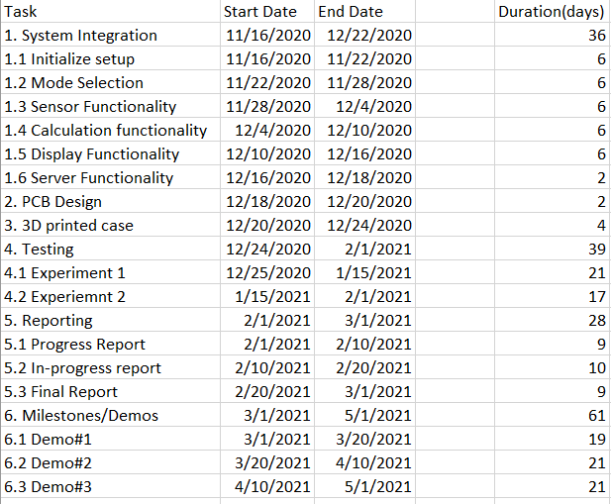
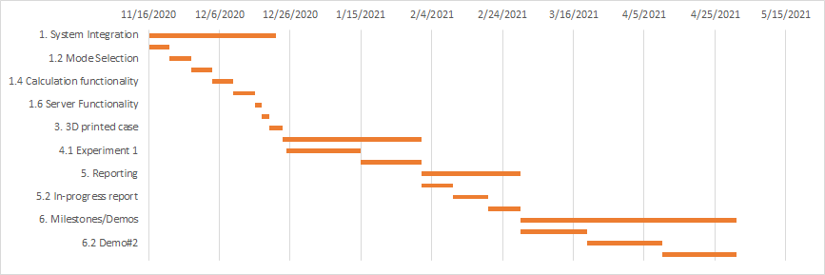

IX. References:
[1] J. M. von der Heiden, B. Braun, K. W. Müller, and B. Egloff, “The association between video gaming and psychological functioning,” Frontiers in psychology. Jul. 2019, DOI: 10.3389/fpsyg.2019.01731.
[2] “Carpal Tunnel Syndrome Fact Sheet,” National Institute of Neurological Disorders and Stroke. Apr. 2020, [Online]. Available:
[3] “How to Send Data to ThingSpeak Cloud using Raspberry Pi.” Jan. 2019. https://iotdesignpro.com/projects/how-to-send-data-to-thingspeak-cloud-using-raspberry-pi .

